Lab 7 Problem 1: Jordan Whittington & Adam Boehnlein

2.Outer Loops: 26

3.Inner Loops: 26\*26 and 26\*10

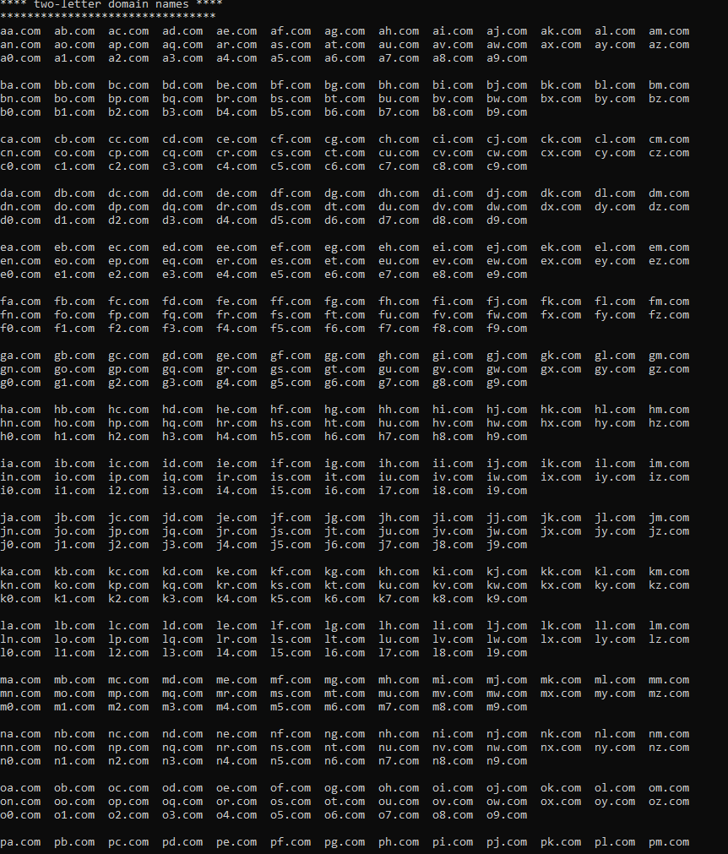

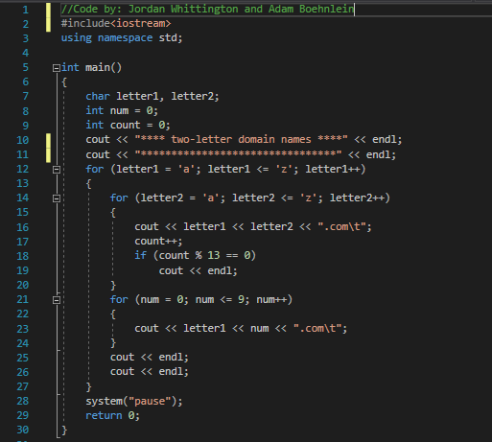

Lab 7 Problem 2:

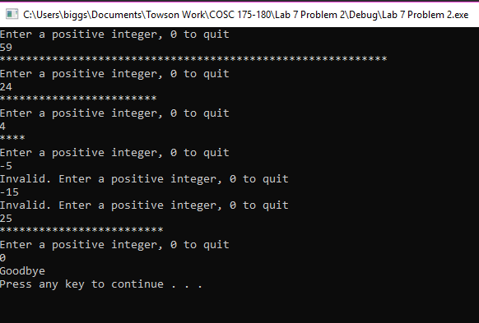

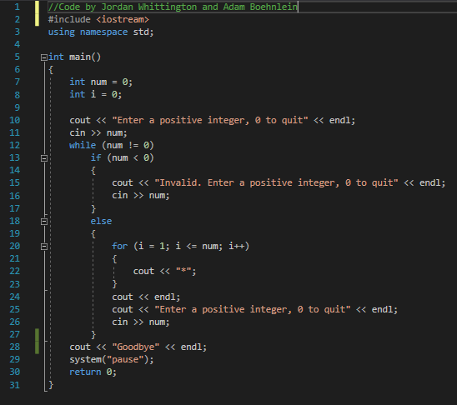

Lab 7 Problem 3:

